The MII — Media Independent Interface
The MII is the electrical and logical boundary between the MAC (Media Access Control) layer and the PHY (Physical layer) inside an Ethernet device. Its defining purpose is captured in its name: the MAC should be able to talk to any PHY — 10BASE-T, 100BASE-TX, 100BASE-FX, fibre, copper — without changing a single wire. The interface is the same regardless of what medium hangs off the other side of the PHY.
It was defined in IEEE 802.3 Clause 22 alongside 100BASE-T in 1995 and remains the conceptual foundation for every MII variant that followed (RMII, GMII, RGMII, SGMII, XGMII).

1. Physical signal overview — what the pins actually are

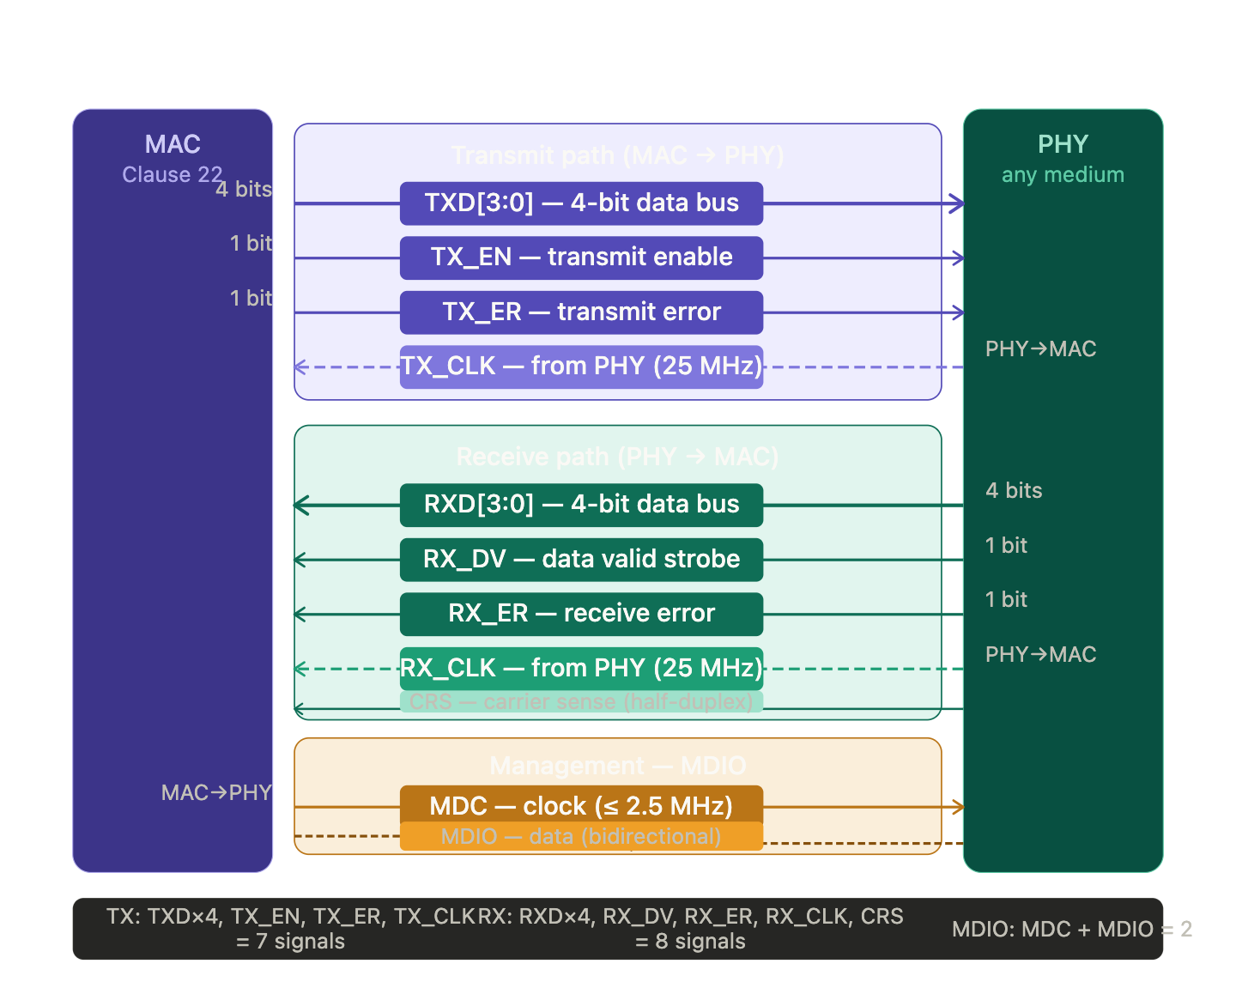

The MII has two completely separate paths — transmit and receive — each with its own independent 4-bit data bus and its own clock. This is not a time-multiplexed bus: both paths can carry data simultaneously, making MII inherently full-duplex at the interface level even when the PHY is operating half-duplex on the medium.
TXD[3:0] — four data bits driven by the MAC to the PHY every rising edge of TX_CLK. At 25 MHz with 4 bits per clock, this gives 100 Mbit/s. At 2.5 MHz it gives 10 Mbit/s. The same physical pins, same interface, different clock frequency — this is how the MII supports both 10 and 100 Mbit/s without any rewiring.
TX_EN (Transmit Enable) — the MAC asserts this high to tell the PHY "the data on TXD is valid, please transmit it." When TX_EN goes low, the PHY sees the end of the frame and begins its end-of-stream signalling on the medium.
TX_ER (Transmit Error) — the MAC asserts this to inject a deliberate coding error into the PHY's output stream. Used for testing and for propagating error conditions. In normal operation it stays low.
TX_CLK — critically, this clock is sourced by the PHY and driven back to the MAC, not the other way around. The PHY recovers its transmit clock from its own PLL (locked to the medium's symbol clock or to a crystal) and hands it to the MAC. The MAC uses this recovered clock to sample its own TXD output. This means the PHY controls the transmit timing — the MAC cannot transmit faster than the PHY is capable of absorbing.
RXD[3:0], RX_DV, RX_ER, RX_CLK — the receive path mirrors the transmit path exactly. The PHY drives four data bits, a data valid strobe, an error indicator, and a clock, all sourced from recovered symbol timing on the medium. The MAC samples RXD on every rising edge of RX_CLK.
CRS (Carrier Sense) — the PHY asserts this when it detects activity on the medium, whether from a local transmit or from an incoming signal. The MAC uses this in half-duplex mode to implement the CSMA/CD algorithm.
COL (Collision) — the PHY asserts this when it detects a simultaneous transmit and receive in half-duplex mode. The MAC responds by stopping transmission and executing the back-off algorithm. In full-duplex mode both CRS and COL are deasserted and ignored.

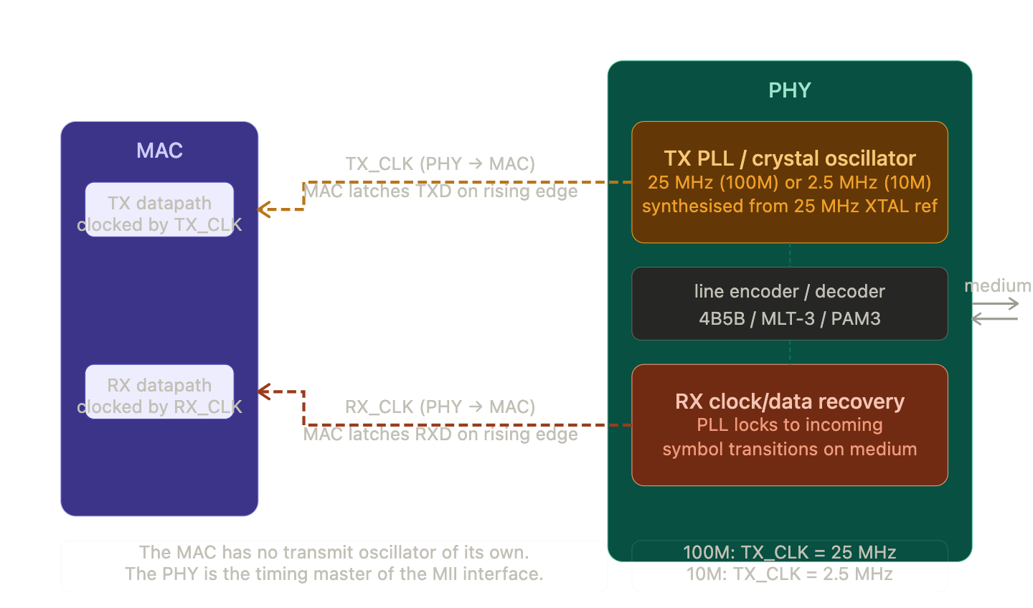
2. The clock architecture — why the PHY drives both clocks

The TX_CLK is synthesised by the PHY's PLL from its crystal reference. The PHY hands this clock to the MAC; the MAC uses it to time the TXD outputs. Because the MAC samples TXD synchronously with TX_CLK, and both are generated in the same PHY silicon, there is no clock domain crossing between TXD and TX_CLK — they have zero skew relative to each other at the PHY's input pins.
The RX_CLK comes from the CDR (Clock and Data Recovery) circuit — a PLL that locks to the incoming symbol transitions on the medium. When a far-end transmitter sends data, its encoded symbols contain transitions; the CDR extracts timing from those transitions and reconstructs a clean clock. This recovered clock drives both the internal receive deserialiser inside the PHY and the RX_CLK output to the MAC. The MAC then uses this recovered clock to latch RXD, ensuring perfect alignment between the incoming data and the clock that was used to generate it at the far end.

3. Transmit timing — how a frame leaves the MAC
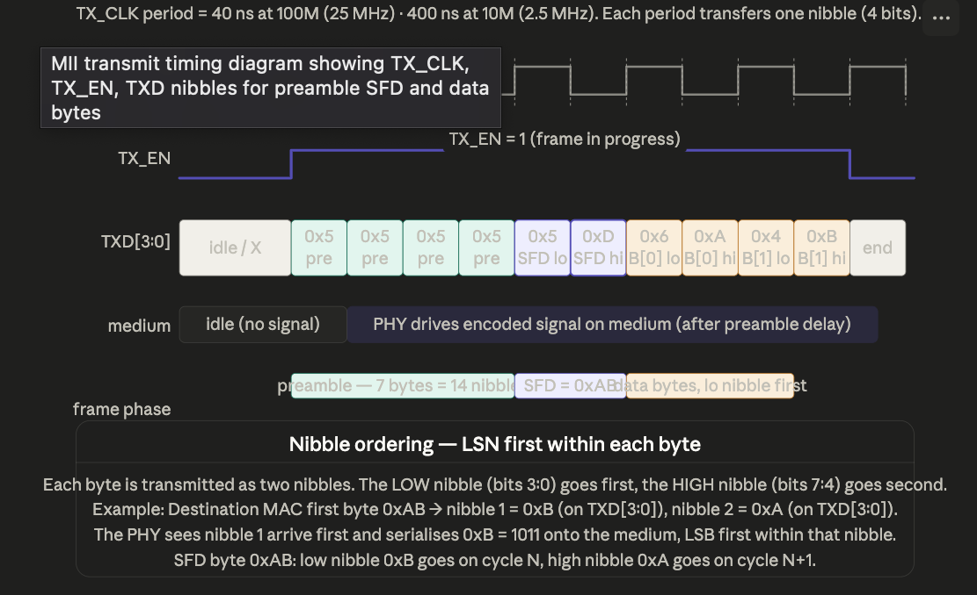

The nibble ordering is counterintuitive but consistent: within each byte, the low nibble (bits 3:0) is driven first, then the high nibble (bits 7:4). The PHY then serialises each nibble onto the medium LSB first. So for a byte value of 0xAB: the MII first presents 0xB = 1011, then 0xA = 1010; the medium receives bits in order: 1, 1, 0, 1, 0, 1, 0, 1.
The preamble is 7 bytes of alternating 1s and 0s (0x55 repeated). On MII this is a stream of 0x5 nibbles. The preamble gives the far-end PHY's CDR time to lock to the incoming clock before any addressable data arrives. The SFD (Start Frame Delimiter) is the byte 0xAB — on MII this appears as nibble 0xB followed by nibble 0xA. The MAC begins driving TX_EN at least one clock before the first preamble nibble and holds it high until the last FCS nibble has been clocked out. On the falling edge of TX_EN the PHY generates its end-of-stream signalling.

4. The MDIO management interface — reading and writing PHY registers
MDIO (Management Data Input/Output) is a two-wire serial interface that gives the MAC (or more precisely the host CPU via the MAC) access to the PHY's internal configuration and status registers. It operates on a completely different clock domain from the data path — at most 2.5 MHz — and is not involved in normal frame forwarding at all.
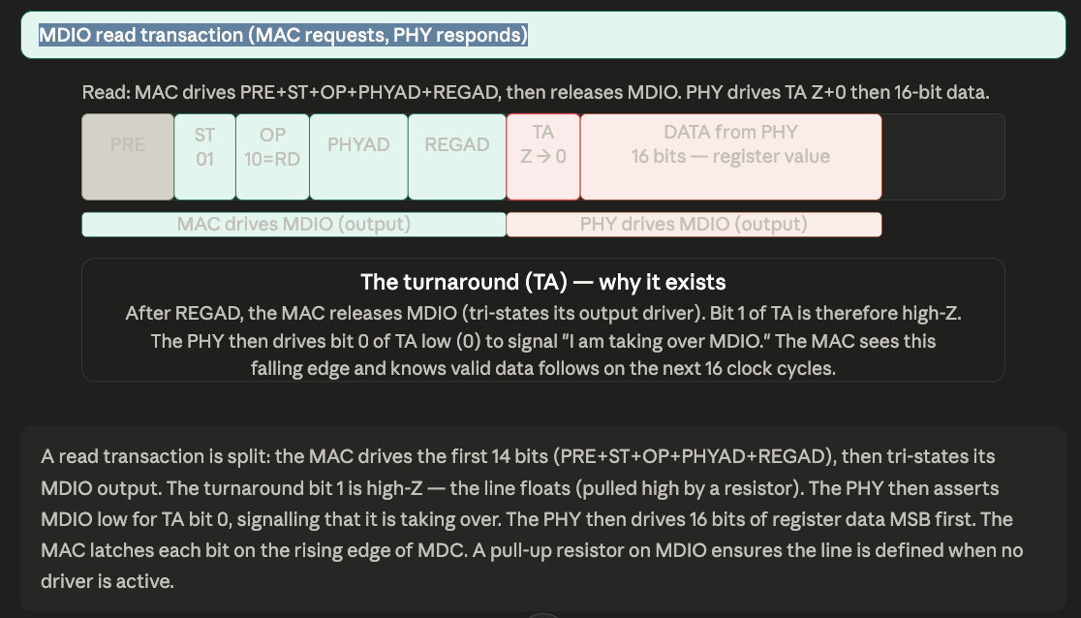
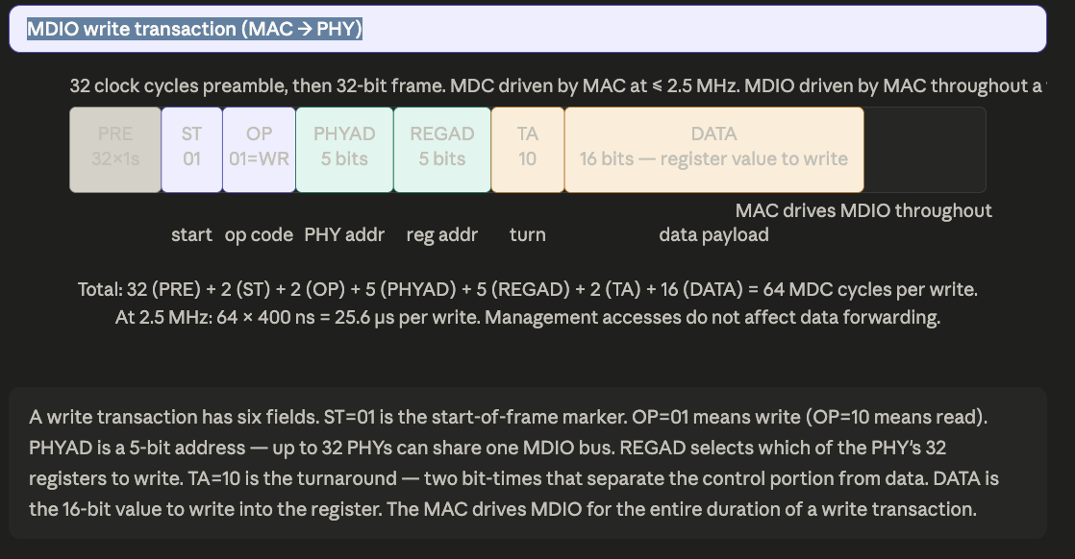

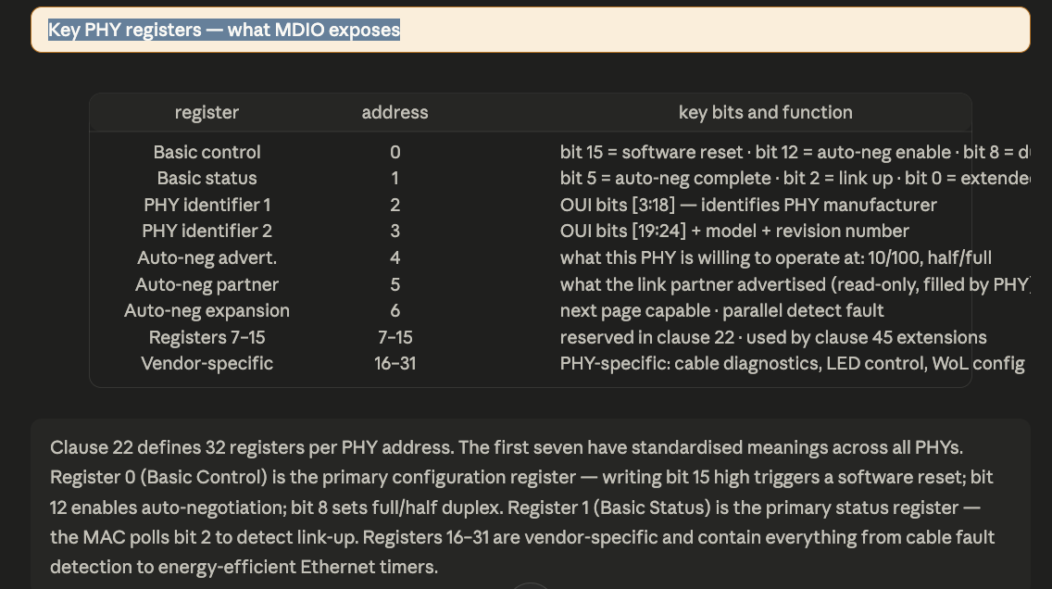
5. The MII family — how the interface evolved

The original MII handles 10 and 100 Mbit/s. As Ethernet speeds increased, the interface needed to evolve. The core ideas — separate TX and RX paths, PHY-sourced clocks, data valid strobes — are preserved in every successor.

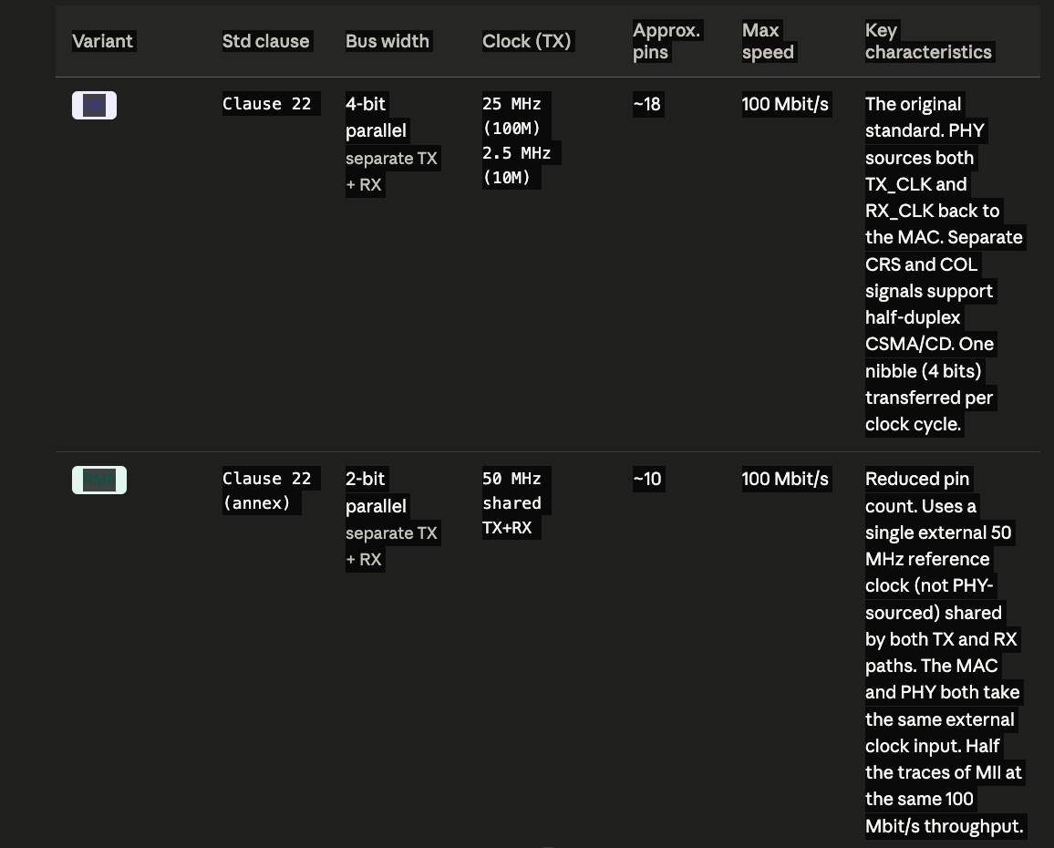

The evolution tells a clear story. MII → GMII simply widened the data bus from 4 to 8 bits and raised the clock from 25 to 125 MHz to hit 1 Gbit/s. RMII went the opposite direction — halved the bus to 2 bits and doubled the clock to 50 MHz, trading throughput at 100 Mbit/s for fewer PCB traces. RGMII kept the 4-bit bus but used DDR (both clock edges), halving pin count versus GMII while maintaining 1 Gbit/s. SGMII abandoned parallel buses altogether and went serial with embedded clock — exactly one differential pair each way. XGMII scaled the parallel bus to 32 bits for 10 Gbit/s but its pin count makes it impractical on PCBs, so it exists almost exclusively as an on-chip interface between PCS and MAC logic inside an ASIC.
In automotive, RGMII is the dominant on-board interface between a switch ASIC and an external PHY chip at 1 Gbit/s, while SGMII is standard for SoC-integrated MAC blocks connecting to external PHYs. MII itself is still found in 100BASE-T1 PHY designs connecting to legacy MACs that were designed for standard 100BASE-TX.

